**Mateusz Twardowski 13847 lab6/1/ISN**

**Cubic function**

1. **Przykładowe wyniki:** (Poprawność kodu sprawdzana w serwisie WolframAlpha)

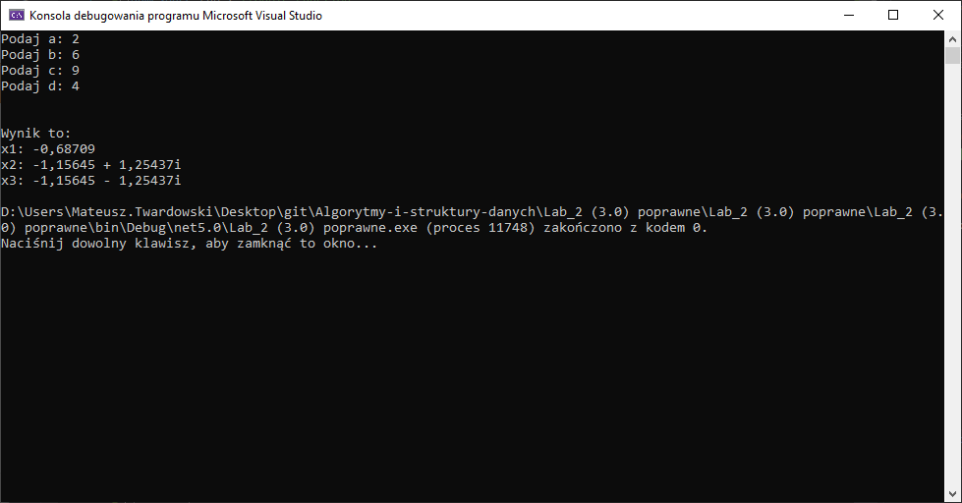

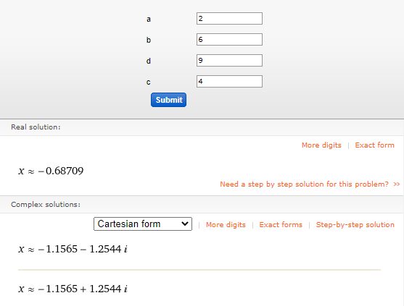

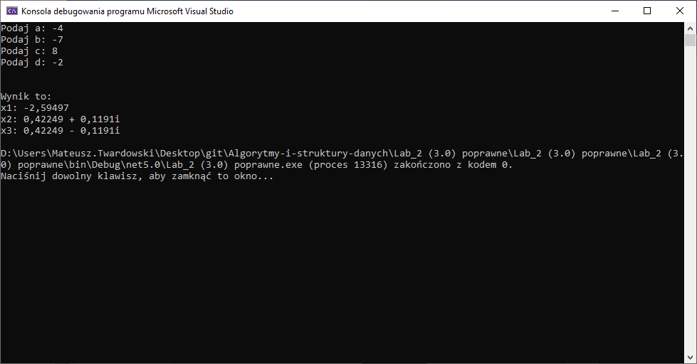

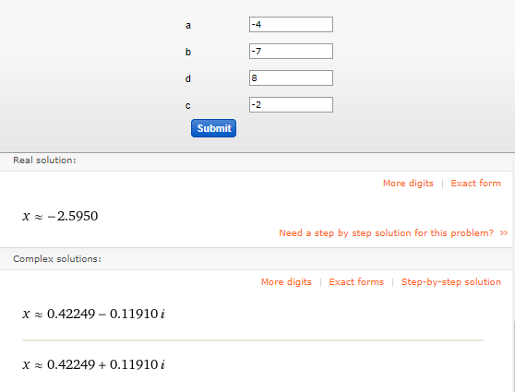

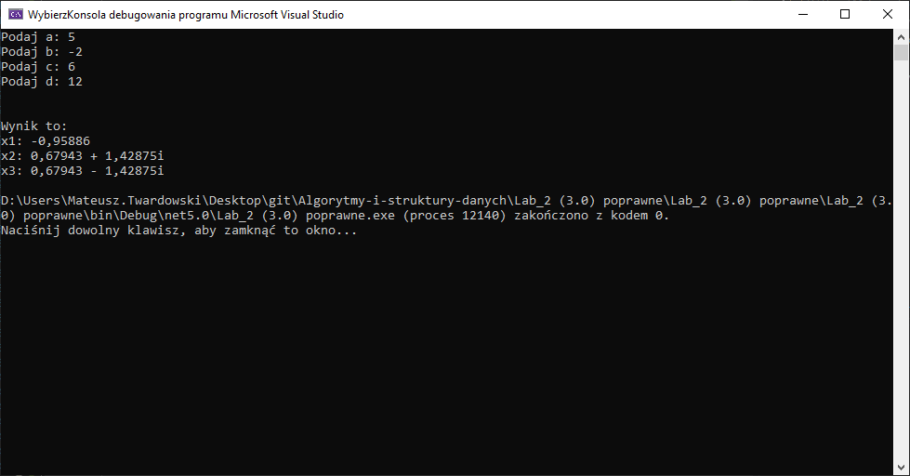

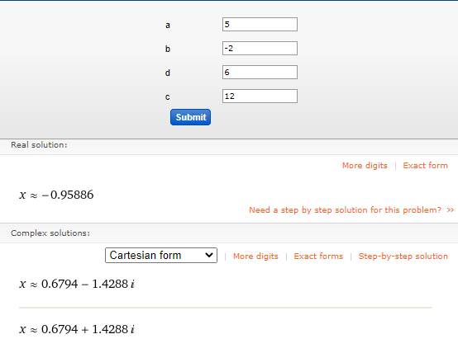

1. **Kod źródłowy:**

using System;

namespace Lab_2 //Qubic Function

{

class Program

{

static void Main(string[] args)

{

double a, b, c, d;

double w, p, q, delta;

double u, v, phi;

string x1, x2, x3;

Console.Write("Podaj a: ");

a = Int32.Parse(Console.ReadLine());

Console.Write("Podaj b: ");

b = Int32.Parse(Console.ReadLine());

Console.Write("Podaj c: ");

c = Int32.Parse(Console.ReadLine());

Console.Write("Podaj d: ");

d = Int32.Parse(Console.ReadLine());

Console.WriteLine(); Console.WriteLine();

Console.WriteLine("Wynik to: ");

if (a == 0)

{

Console.WriteLine("Błąd danych - wprowadzono a=0");

return;

}

w = -b / (3 * a);

p = ((3 * a * Math.Pow(w, 2)) + (2 * b * w) + c) / a;

q = ((a * Math.Pow(w, 3)) + (b * Math.Pow(w, 2)) + (c * w) + d) / a;

delta = (Math.Pow(q, 2) / 4) + (Math.Pow(p, 3) / 27);

if (delta > 0)

{

u = Math.Cbrt(-(q / 2) + Math.Sqrt(delta));

v = Math.Cbrt(-(q / 2) - Math.Sqrt(delta));

x1 = "" + Math.Round(u + v + w, 5);

x2 = "" + Math.Round((-((u + v) / 2) + w), 5);

x2 += " + " + Math.Round((Math.Sqrt(3) / 2) * (u - v), 5);

x3 = "" + Math.Round((-((u + v) / 2) + w), 5);

x3 += " - " + Math.Round((Math.Sqrt(3) / 2) * (u - v), 5);

Console.WriteLine($"x1: {x1}");

Console.WriteLine($"x2: {x2}i");

Console.WriteLine($"x3: {x3}i");

}

if (delta < 0)

{

phi = Math.Acos(3 * q / (2 * p * Math.Sqrt(-p / 3.0)));

x1 = "" + Math.Round(w + (2 * Math.Sqrt(p / 3.0) * Math.Cos(phi / 3)), 5);

x2 = "" + Math.Round(w + (2 * Math.Sqrt(p / 3.0) * Math.Cos(phi / 3 * (2 / 3 * Math.PI))), 5);

x3 = "" + Math.Round(w + (2 * Math.Sqrt(p / 3.0) * Math.Cos(phi / 3 * (4 / 3 * Math.PI))), 5);

Console.WriteLine($"x1: {x1}");

Console.WriteLine($"x2: {x2}");

Console.WriteLine($"x3: {x3}");

}

if (delta == 0)

{

x1 = "" + (w - 2 * Math.Cbrt(q / 2.0));

x2 = "" + (w + Math.Cbrt(q / 2.0));

Console.WriteLine($"x1: {x1}");

Console.WriteLine($"x2,x3: {x2}");

}

}

}

}